Date:
EXPERIMENT 1: DDL Commands – CREATE, ALTER, DROP

AIM:
To create, alter, drop, rename and truncate tables using Data Definition Language (DDL) statements for a Drone Delivery Management System.

DESCRIPTION:
Data Definition Language (DDL) statements are used to define the database structure or schema.
In this experiment, we design the database for a Drone Delivery System which manages drones, customers, hubs and delivery orders.
DDL Commands used:
- CREATE – to create tables (DRONE, CUSTOMER, HUB, ORDERS)
- ALTER – to modify table structure (add LastMaintenance column)
- DROP – to delete tables
- TRUNCATE – to remove all records from a table
- RENAME – to rename an object

PROCESS:
Step 1: Start
Step 2: Create a database named drone_delivery
Step 3: Select the database using USE command
Step 4: Create table DRONE with attributes: DroneID, Model, MaxPayload, BatteryLevel, Status, HubID
Step 5: Create table CUSTOMER with attributes: CustID, CustName, Gender, MobileNo, Address, City
Step 6: Create table HUB with attributes:HubID, HubName, HubManager, Capacity
Step 7: Create table ORDERS with attributes: OrderID, CustID, DroneID, OrderDate, Status, DeliveryAddress
Step 8: Alter the DRONE table by adding a new column LastMaintenance of type DATE Step 9: Verify the structure of all tables using DESC command
Step 10: Stop

OUTPUT
QUERY 1:
CREATE DATABASE IF NOT EXISTS drone_delivery;
USE drone_delivery;

DROP TABLE IF EXISTS orders;
DROP TABLE IF EXISTS drone;
DROP TABLE IF EXISTS customer;
DROP TABLE IF EXISTS hub;

CREATE TABLE drone (
DroneID VARCHAR(6),
Model VARCHAR(20),
MaxPayload DECIMAL(5,2),
BatteryLevel INT,
Status VARCHAR(15),
HubID VARCHAR(4)
);
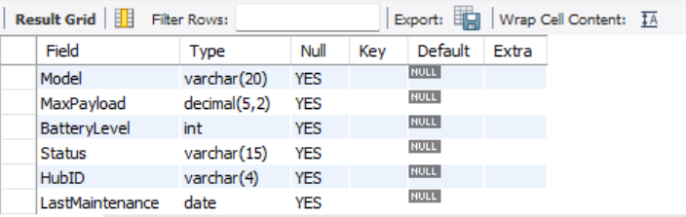
QUERY 2:
CREATE TABLE customer (
CustID VARCHAR(6),
CustName VARCHAR(25),
Gender CHAR(1),
MobileNo BIGINT,
Address VARCHAR(50),
City VARCHAR(20)
);
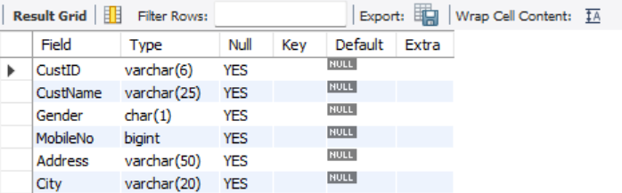

QUERY 3:
CREATE TABLE hub (
HubID VARCHAR(4),
HubName VARCHAR(25),
HubManager VARCHAR(6),
Capacity INT
);
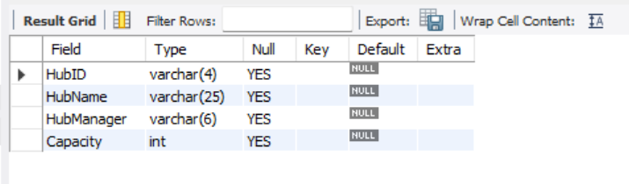
QUERY 4:
CREATE TABLE orders (
OrderID VARCHAR(8),
CustID VARCHAR(6),
DroneID VARCHAR(6),
OrderDate DATE,
Status VARCHAR(15),
DeliveryAddress VARCHAR(50)
);

ALTER TABLE drone ADD LastMaintenance DATE;

DESC drone;
DESC customer;
DESC hub;
DESC orders;

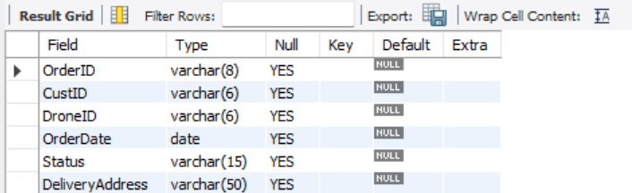



RESULT:
Tables for the Drone Delivery System are successfully created and modified using DDL commands.

